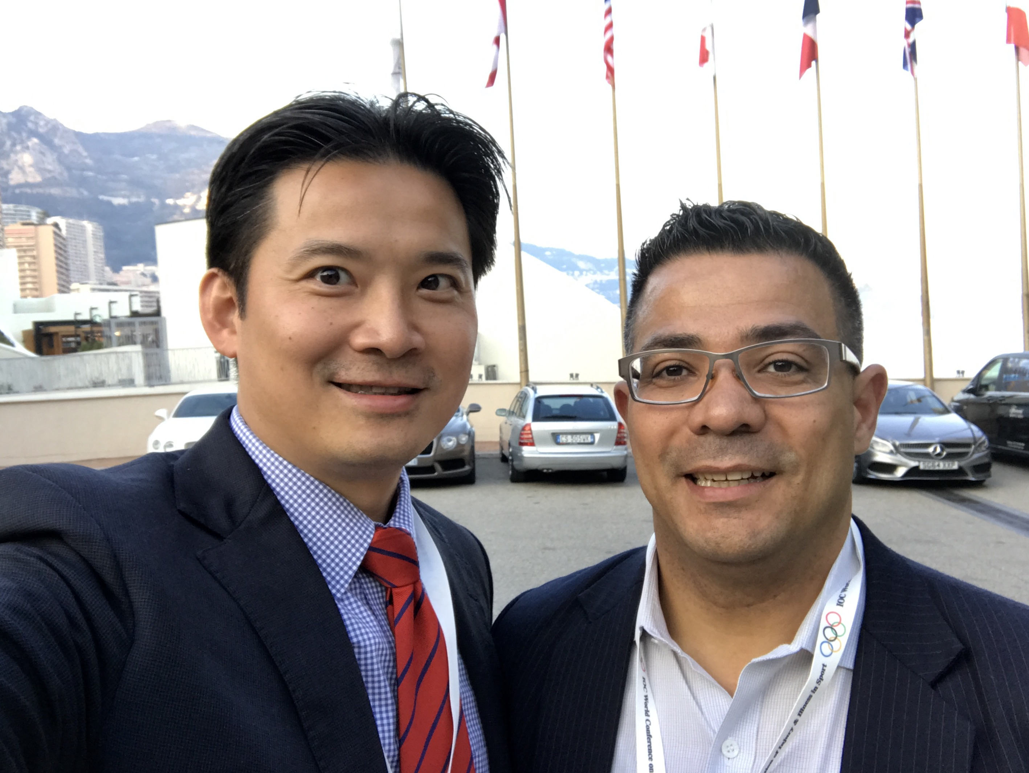
Dr. Victor Lopez, Jr., D.O.

Research specialization: Sports injury epidemiology and prevention, Olympic rugby development player’s injury risk, in a strategic growing rugby market.

Experience: Prior to collaborations with AUT/SPRINZ since 2014, Dr. Lopez was surgically trained in the North Shore-LIJ Hospital System, NY (currently Northwell Health), is a current Clinical Affiliated Investigator, and the Founder and Executive Director of the Research Institute for Sports and Exercise (RISE Institute), at Hospital for Special Surgery (HSS) an International Olympic Committee-Medical Centre, he also Founded and is Executive Director of the Rugby Research and Injury Prevention Group (2009-21) (www.rugbyinjury.org), and Director of Medical Services for the Northeast Academy (2014-2019), a USA Rugby Sanctioned Development Academy, with its elite team, the New York City World Club 7s Squad, and the youth-aged US Olympic Committee, Community Olympic Development Programme (USOC-CODP). That travelled the North American playing circuit (Barbados, Costa Rica, Canada & the USA) Teaching spans high school advanced science program, undergraduate to post-graduate residents in Sports Medicine and Surgery. Dr Lopez has presented at major sports conferences; AOSSM, ACSM, BASES, ISAKOS, ISBS, SMA and the IOC World Conference on Prevention of Injury and illness in Sport. In 2019 he chaired the SMA Symposium on Rugby Union 7s and 15s Injury Prevention Symposium anchored by Prof Patria Hume. In 2021 Dr. Lopez will be the Rugby-7s IOC workshop co-presenter with his colleague Dr Richard Ma, on Rugby-7s Injury prevention, guided by his mentor Prof Patria Hume. Dr Lopez’s combination of rugby science/sports medicine with rugby playing experience enables an understanding of the needs in safety and injury prevention.

Research overview: Dr. Lopez conducts rugby research (amateur to elite) across North America. Despite its growing popularity in the U.S., there is a lack of rugby-related injury data on North America. This is due in part to the sport being predominantly a club sport, as well as lack of inclusion in existing injury surveillance systems. His aims are to gain a preliminary data set of rugby knowledge on safety, player history, past injuries and mechanisms of injury; and ascertain trends to assist in player welfare and safety; and apply the Rugby Injury Survey and Evaluation (RISE) data collection methodology. Which has matured to a 10-year dataset, this 2021, on US injury data. To assist healthcare providers to understand the risk factors for rugby-related injuries and make safe return-to-play decisions and decrease the likelihood of re-injury to players. This may in turn, nurture the development of the large pool of athletic talent to progress from youth rugby to the elite level and possible national candidates. Dr Lopez is fortunate to be working towards his PhD at AUT/SPRINZ, on “Risk factors in US Rugby-7s” with supervisors, Dr. Answorth A. Allen, the concussion expert Dr. Robert C Cantu, Professor Meryle Weinstein & Professor Patria Hume. He works closely with USA Rugby and the Empire Geographic Union (GU) RFU & New England GU RFU. As Co-Principle Investigator of a 2-year prospective injury epidemiological study of Rugby-7s in North America, sponsored by Hospital for Special Surgery and the National Operating Committee on Standards for Athletic Equipment, he attends greater than 50 USA Rugby sanctioned U.S. tournaments, including the USA Rugby Club Championships (for 10 years) and other major events: HSBC Las Vegas Rugby-7s and the Penn Mutual Collegiate Rugby Championships.
Postgraduate supervision: Multiple residents and Fellows senior papers, 2 Masters research students to completion. Currently supervising 3 Masters: Application of an injury prevention programme for U.S. Rugby; Rugby-7s risk in a multiple match format.
Research publications: Examples representative of Dr. Lopez’s previous and ongoing work include:
- Lopez V, Jr., Ma, R, Weinstein MG, Hume PA, Cantu RC, et al. Effects of U.S. Rugby-7s players’ competition level and playing position on injury incidence, severity and characteristics: a prospective cohort study of pre-professional injury rates. CJSM. (to be submitted Nov 2021)
INCLUDEPICTURE "http://rugbyinjury.org/wp-content/uploads/2017/02/Rugby-Logo-700x114.png" \* MERGEFORMATINET
Dr. Victor Lopez, Jr., D.O.
Founder and Exec. Director, Rugby Research & Injury Prevention Grp, Clinical Affiliated Investigator, Hospital for Special Surgery, Director Medical Services (2014-19) Northeast Academy.
118-17 Union Turnpike, Suite 3B, New York NY, USA
M: + 01 (917) 533 1021
E: DrVictorLopezJr@gmail.com
INCLUDEPICTURE "http://rugbyinjury.org/wp-content/uploads/2017/02/NE-Academy-Rugby.png" \* MERGEFORMATINET
- Lopez V, Jr., Ma, R, Weinstein MG, Hume PA, Cantu RC, et al. United States Rugby-7s under-19 tournament players injury rates during a 5-year epidemiological study. Sports Med Open. 2020 Aug 27;6(1):41. doi: 10.1186/s40798-020-00261-y
- Lopez V, Jr., Victoria C, Ma R, Weinstein MG, Hume PA, Haleem SY, Mettry MT, Quteishat B & Allen AA. Prevalence and Cause of Non-contact Injury Mechanisms in US Men’s Rugby-7s. ISBS Proceedings Archive: 2019 Vol.37, 1:44 At: https://commons.nmu.edu/isbs/vol37/iss1/44.
- Lopez V, Jr., Ma, R, Weinstein MG, Hume PA, Cantu RC, Victoria C, Haleem SY, DeLallo JF & Allen AA. Biomechanical Contact Injury Influences in USA Men’s Rugby-7s. ISBS Proceedings Archive: 2018 Vol.36, 1:125. At: https://commons.nmu.edu/isbs/vol36/iss1/125.
- Ma R, Lopez V, Jr., Weinstein MG, Chen JL, Black CM, et al. Injury Profile of American Women Rugby-7s. MSSE. 2016 Oct;48(10):1957-66.PMID:27232243
- Lopez V, Jr., Ma, R, Weinstein MG, Cantu RC, Myers LSD, et al. Concussive Injuries in Rugby-7s: An American Experience and Current Review. MSSE 2016 Jul;48(7):1320-30. PMID: 26829001
- Lopez Jr. V, Ma R, Weinstein MG, Chen JL, Black CM, et al. An American Experience with a New Olympic Collision Sport: Rugby-7s. OJSM. 2014 Jul; 2(2S); DOI: 2325967114S00056.
- Lopez V, Jr., Galano GJ, Black CM, Gupta AT, James DE, Kelleher, K, Allen AA. Profile of an American Amateur Rugby Union Sevens Series. AJSM. 2012; 40(1):179-184. PMID: 22102102

