RUGBY CODES RESEARCH GROUP – MEMBER

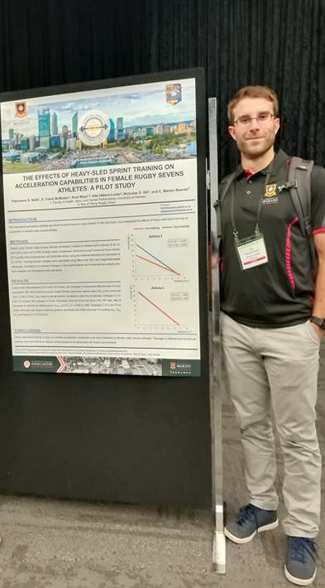
Francesco S. Sella

PhD Candidate,
University of Waikato Adams Centre for High Performance

Research specialisation: Women’s rugby, rugby sevens, strength and conditioning.

Experience: Strength and conditioning coach in rugby sevens and rugby union (Black Ferns Sevens, Bay of Plenty Rugby Union).

Research overview:
His PhD project is investigating methods to maximise physical performance in female rugby athletes.

Postgraduate supervision: One Masters thesis student to completion (Universitá degli Studi di Milano, Milano, Italy).

Research publications:
Sella FS, McMaster DT, Beaven CM, Gill ND, Hébert-Losier K. Match demands, anthropometric characteristics, and physical qualities of female rugby sevens athletes: A systematic review. The Journal of Strength and Conditioning Research. Accepted for publication, July 2019.

Sella FS, McMaster DT, Serpiello FR, La Torre A. Match analysis in rugby union: Performance indicators of Rugby Championship and Super Rugby teams. The Journal of Sports Medicine and Physical Fitness, 59: 1306-1310, 2019.

Francesco S. Sella
PhD Candidate
University of Waikato Adams Centre for High Performance

E: fss4@students.waikato.ac.nz
52 Miro St, Mount Maunganui, Tauranga, 3116

1

