**Prof. Mike Hamlin**

PhD(Otago), MHMS(Uni of Queensland), BPhEd(Otago).

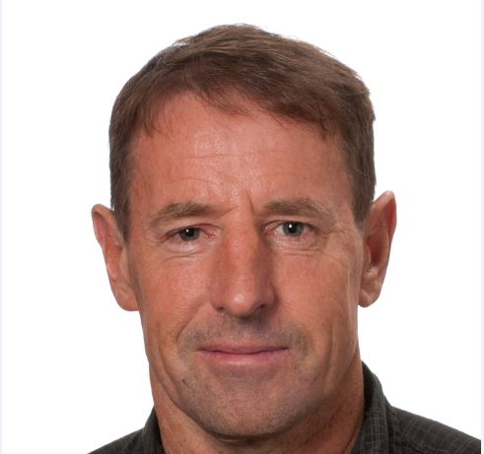

**Research specialisation:** Exercise Physiology, Training, Altitude and Hypoxia, Injury

**Experience:** Over 20 years of research experience into elite and sub-elite sportspeople. Worked with athletes from Bike NZ, Triathlon NZ, NZ Rugby, and Canterbury Rugby, Netherlands Triathlon Team. Fellow of the American College of Sports Medicine, Fellow of the European College of Sport Science and Fellow of Sport Science New Zealand.

**Research overview:** Mike's research areas include exercise physiology, the health effects of physical activity and performance-related aspects of elite athletes, in particular the use of altitude and hypoxic training to enhance performance. Mike has been involved in a number of altitude training projects (both real and simulated); with a number involving rugby players. More recently, Mike has conducted a number of projects on athletes using intermittent hypoxic training. Mike’s research also involves analysing the training effects and how these affect stress within the athlete and how this can be monitored to and used to improve training response and recovery.

**Postgraduate supervision:** Currently supervising three PhD students in the areas of flexibility and training effect on health and performance, internal and external load parameters in elite team sport athletes and exercise with chronic kidney disease patients.

**Research publications:** 115 peer reviewed publications, over 100 conference presentations and 1 book. Editor for the following publications; Journal of Sport and Exercise Science, Frontiers in Sports and Active Living -Elite Sports and Performance Enhancement, Slovak Journal of Sports Science, Archives of Allied Health Sciences.

Example publications:

**Hamlin, M.J**., Deuchrass, R.W., Olsen, P.D., Choukri, M.A., Marshall, H.C., Lizamore, C.A., Leong, C., Elliot, C.A. The effect of sleep quality and quantity on athlete’s health and perceived training quality. *Frontiers in Sports and Active Living* 3:705650, 2021.

**Hamlin, MJ**. Lizamore, CA. Olsen, PD. Marshall, HC. Monitoring heart rate variability and subsequent performance in team-sport athletes receiving hypoxic or normoxic repeated sprint training. *Archives of Allied Health Science* 33(1) 9-18, 2021.

Busbridge, A.R. **Hamlin, M.J**. Jowsey, J.A. Vanner, M.H. and Olsen, P.D. Running demands of provincial women’s rugby union matches in New Zealand. *Journal of Strength and Conditioning* ***Research* (In Press).**



**Mike Hamlin (PhD)**

Professor of Exercise & Sport Science,

Department of Tourism, Sport and Society

Lincoln University, P.O. Box 85084, Lincoln 7647, New Zealand

**M: + 64 (0) 212572600**

**E: mike.hamlin@lincoln.ac.nz**

Lincoln University Campus

Cnr. of Ellesemere Junction and Springs Roads, Christchurch, New Zealand

**

**Hamlin, MJ**. Deuchrass, RW., Elliot, CE., Manimmanakorn, N. Short and long-term differences in anthropometric characteristics and physical performance between male rugby players that became professional or remained amateur. *Journal of Exercise Science and Fitness* 19 143-149 2021. https://doi.org/10.1016/j.jesf.2021.01.002

Muangritdech, N., **Hamlin, M.J**., Sawanyawisuth, K., Prajumwongs, P., Saengjian, W., Wonnabussapawich, P., Manimmanakorn, N., Manimmanakorn, A. Hypoxic training improves blood pressure, nitric oxide and hypoxia-inducible factor-1 alpha in hypertensive patients. *European Journal of Applied Physiology* 120(8) 1815-1826, 2020.

**Hamlin, M.J.,** Deuchrass, R. Elliot, C.E., Raj, T. Promkeaw, D. Phonthee, S. Effect of a 6-week exercise intervention for improved neck muscle strength in amateur male rugby union players. *The Journal of Sport and Exercise Science* 4(1) 33-39, 2020.

Takamori, S., **Hamlin,** M.J. Kieser, D.C., King, D., Hume, P., Yamazaki, T., Hachiya, M., Olsen, P.D.Senior club-level rugby union player’s positional movement performance using individualised velocity thresholds and accelerometer-derived impacts in matches. *J Strength & Conditioning Research* (DOI: [10.1519/jsc.0000000000003523](https://doi.org/10.1519/jsc.0000000000003523))