LITTLE GIRLS TO ADVANCED GYMNASTS: WHAT CAN WE LEARN FROM THE SURVIVING GYMNASTS?
Kylie Thomas¹ and Elizabeth J. Bradshaw^{2,3}
Cricket Australia, Brisbane, Australia¹
Centre for Sport Research, School of Exercise and Nutrition Sciences, Deakin University, Melbourne, Australia²
Sports Performance Research Institute New Zealand, Auckland, New Zealand³

Talent identification programmes are widely employed in gymnastics to select young girls whom are thought to exhibit the pre-requisite traits to excel at the elite level in the future. This study revisits the Thomas, Wilson, and Bradshaw (2013) paper on 5-8 year old talent selected artistic gymnasts. The Gymnastics Victoria and Gymnastics Australia websites were data mined to track the competition history of these gymnasts. The original data (e.g. anthropometry, jump biomechanics) of the gymnasts that survived to an advanced level were compared against those whom did not, using the Kruskal Wallis test. The analysis revealed that better drop jump performance was the key indicator of longer term talent potential. Prospective analysis on surviving gymnasts provides better insights on the key attributes related to future advanced gymnastics potential.

KEY WORDS: talent, anthropometry, biomechanics, motor skill, gymnastics.

INTRODUCTION: The attributes of an elite artistic gymnast is multifaceted due, in part, to the complexity of the sport (Prescott, 1999). Whilst the sport has grown and matured to include opportunities for international competition for apparatus specialists, early development requires these athletes to still train and master each apparatus to a high level. In female artistic gymnastics this requires committed training over at least a decade on four apparatus (beam, bars, floor, vault), in addition to supplementary training including conditioning and ballet. The time and financial investment in developing talent in this sport is therefore considerable.
Gymnastics training provides a number of positive benefits (e.g. increased bone mineral density and reduced risk of osteoporosis later in life), however elite training opportunities are limited by geography, funding, family support, and other factors. Identifying traits in young gymnasts known to correlate highly with later success in the sport is therefore important.
In 2011, 16 talent identified female gymnasts aged 5 to 8 years completed a battery of tests including anthropometry, flexibility, strength, motor skills, and biomechanics (Thomas, Wilson, Bradshaw, 2013). A number of the physical tests revealed significant age effects or displayed large group variation, however many of the anthropometry measures such as leg and arm length, and also torso shape (V ratio), revealed a homogenous group when accounting for age, largely due to talent selection based on body shape. Subjective assessments of body shape and some anthropometry measures are a common element of talent identification programmes. Whilst this assessment may be an important first step, it provides no insight on the innate physical skills that may be required to succeed in this complex sport.
The purpose of this paper was to identify the key physical and biomechanical characteristics of the young gymnasts from the Thomas, Wilson, and Bradshaw (2013) study whom went onto advanced gymnastics.

METHODS: The Thomas, Wilson, and Bradshaw (2013) study collected anthropometry, sport specific strength, flexibility, motor skills and biomechanical jumping ability data. The complete dataset included 18 pre-competitive, talent-identified gymnasts aged 4 to 9 years (Height = 121.51 ± 5.79 cm; Mass = 20.74 ± 2.31 kg), however the 4 (n=1) and 9 (n=1) year old gymnasts were removed from the subsequent analysis and conference paper. All of the gymnasts were part of a youth development squad at a state, high performance training centre, training 5 to 20 hours per week, and were injury-free at the time of testing. For full methods on the original data set, please see the Thomas et al. (2013) paper. Further (new) analyses of the complete data set included reactive strength index (RSI) which was calculated as a ratio of flight time divided by contact time for the drop jump test data. In other sports such as basketball, RSI is often used to profile the athlete’s stretch-load tolerance for different drop heights and has been correlated with training and competition performance (Markwick, Bird, Tufano, Seitz, Haff, 2015).
The original data set was collected during the last week of November in 2011 at the gymnasts training centre. Competition records of these gymnasts was data mined on the Gymnastics Victoria and Gymnastics Australia websites for subsequent years until the end of 2018. Further, a Google search engine was also used, when needed, using the terms of “gymnast’s name”, “gymnastics”, and “Australia”. This enabled gymnasts whom competed in club-based competition, and not state or national competition in a given year to still be captured. That situation may occur when a gymnast misses state or national competition due to injury. It also enabled information on gymnasts whom transferred to another discipline (e.g. rhythmic) or sport to be tracked. The highest artistic gymnastics level of the gymnasts was identified, and whether they were still competing in 2018. In 2018 the original gymnasts would be aged 11 to 16 years and competing in pre-junior to junior competitions. Due to the current age of these gymnasts in 2018, advanced artistic gymnastics was defined as national or international development stream level 8 or higher.
SPSS software (version 25, IBM, Armonk, New York, United States of America) was used for statistical analysis in this paper with an alpha level of 0.05 used to identify significant relationships or effects depending on the analysis tool employed. Kruskal-Wallis one-way analysis was used to identify significant differences between the groups of gymnasts. This method of non-parametric statistical analysis was used due to the resultant independent samples (groups) of different sizes. These analyses were run as follows: (1) any gymnasts whom had historically competed in advanced artistic gymnastics in any given year since the original study against those whom did not, and (2) any gymnast whom was competing in advanced gymnastics in 2018 against those whom did not. Identified tests and measures, if any, were then used as the outcome (dependent measure) in stepwise linear regression modelling. The linear regression modelling was used to identify whether any other tests and measures (independent measures) were related to the outcome.

RESULTS: Seven of the original gymnasts survived to the advanced gymnastics levels, from which five gymnasts were still competing in 2018. Overall, 13 out of the 18 gymnasts (72%) had dropped out of artistic gymnastics by the end of 2015. Two of these gymnasts transferred to rhythmic gymnastics, and one to athletics. Regardless of whether the gymnast was still competing in 2018, the drop jump from a height of 40 cm was the key test identifying those original gymnasts whom would reach the advanced levels. Specifically, drop jump displacement height was the key measure with and without normalisation with respect to leg length (trochanterion-tibiale laterale [femur] + tibiale mediale-sphyrion tibiale [tibia]) (Figure 1A), as well as drop jump flight time (Figure 1B). A trend was also identified for squat jump impulse when normalised with respect to body weight (Figure 2). It should be noted that differences between the two groups of gymnasts were not identified for any the physical (anthropometry, flexibility, abdominal strength) measures (e.g. tibia length; H = 0.088, p = 0.767).
Normalised average and maximum displacement during the 40 cm drop jump test was selected for further statistical analysis using linear regression modelling. This was due to these measures showing the strongest statistical difference between groups. For this modelling the drop landing and drop jump tests were removed from the independent measures due to their similarity to the dependent measure (40 cm drop jump displacement). Maximum countermovement jump impulse performance observed across three trials was the strongest independent measure that was revealed from the stepwise modelling for average displacement performance (y = 394.163 x – 44.202; R² = 0.348, p = 0.010; where y = average normalised 40 cm drop jump displacement as a percentage of leg length, x = maximum countermovement impulse in body weights per second). However this linear model had only a moderate correlation. Maximum countermovement jump impulse was also revealed from the stepwise modelling for maximum displacement performance (y = 394.574 – 39.133 x; R² = 0.313, p = 0.016; where y = maximum normalised 40 cm drop jump displacement as a percentage of leg length, x = maximum countermovement impulse in body weights per second). The second linear model also only had a moderate correlation. Maximum countermovement impulse was 0.2119 ± 0.0145 BW.s for the gymnasts who reached an advanced level, which were only marginally higher than for the gymnasts who did not (0.1946 ± 0.02964 BW.s; H = 1.725, p =0.189). Specifically, when maximum countermovement impulse was measured in isolation it was not able to statistically separate the two groups.

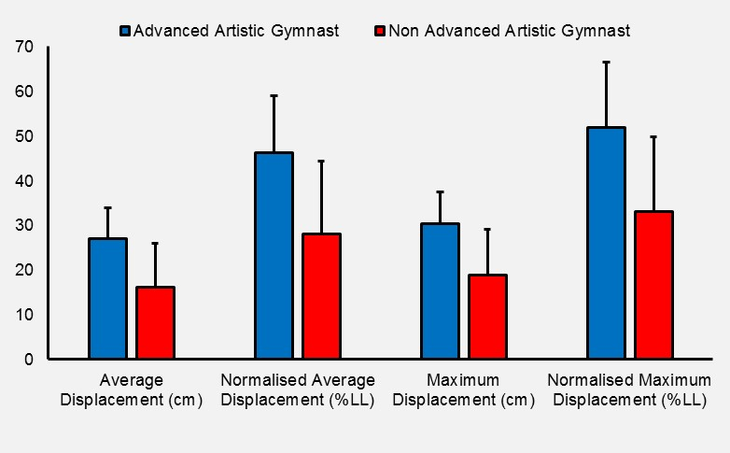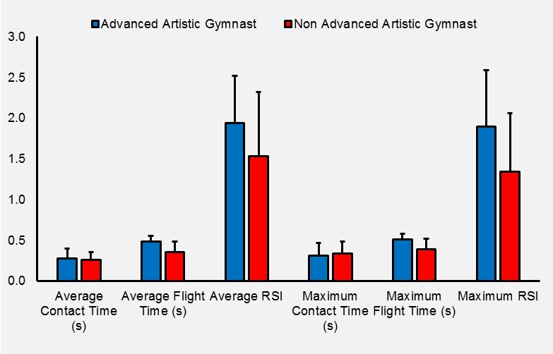
H = 0.002
p =0.961
H = 0.119
p = 0.730
H = 2.233
p = 0.135
H = 2.512
p = 0.113
B
A
H = 4.919
p=0.027*
H = 4.919
p=0.027*
H = 6.203
p=0.013*
H = 5.760
p=0.016*
H = 6.662
p=0.010*
H = 5.760
p=0.016*
Figure 1: 40 cm drop jump performance of those gymnasts whom reached an advanced level versus those who did not, where average is the mean performance across 3 trials, maximum is the best performance across 3 trials, and LL denotes leg length. Statistical results are reported as Kruskal-Wallis H (H), with significant results identified as *p<0.05.
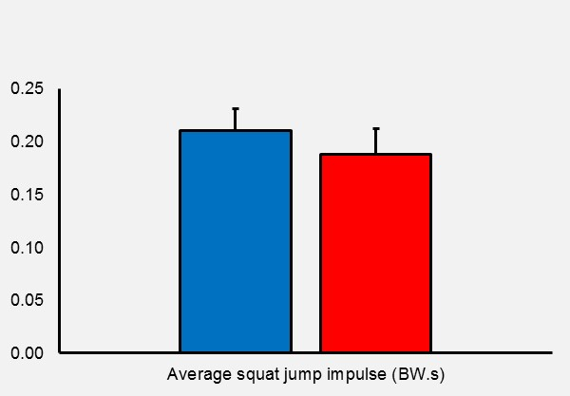
H = 3.792
p=0.052
Figure 2: Average squat jump performance of those gymnasts whom reached an advanced level versus those who did not, where BW is body weight. Statistical results are reported as Kruskal-Wallis H (H) and the significance (p).

DISCUSSION: The assessment of sports-specific strength and power qualities through biomechanical testing on a force platform provides objective information that can be used to guide talent selection and training (Markwick et al., 2015). In this paper, drop jump displacement was identified as a potential biomechanical marker of advanced gymnastics potential. This test requires the gymnast to demonstrate high levels of strength and power under eccentric loading conditions. More specifically, this test uses a fast stretch-shortening cycle (SSC) response that predominantly uses the ankle joint and is sensitive to plyometric training (Kubo, Morimoto, Komuro, Yata, Tsunoda, Kenehisa, Fukunaga, 2007). Interestingly, whilst a reactive strength index (RSI) is widely employed in other sports by strength and conditioning practitioners, that simple ratio was not relevant in this population for the purpose of talent identification due to the high test variability (standard deviations). This may be due to the small sample size, age of the athletes, the elastic floor surface, the faster velocity of the impact, and because it is performed without athletic shoes i.e. barefoot. The widespread use of RSI may be due, in part, to difficulties accessing and/or using a force platform during regular training. Therefore, if simpler alternative measures are required such as through using contact mat or video technology, measures of flight time are recommended.
Plyometric hopping and jumping is characteristic of floor apparatus training in artistic gymnastics, as well as during the running/sprinting required for the vault approach and many apparatus mounts for beam and bars. As explosive jumping ability, in particular, is a precursor for many gymnastics skills (e.g. Arabian or full-in on floor; ability to connect skills such as a back layout somersault 1½ twist to a punch front tuck somersault) it is therefore not surprising that this attribute may be a potential marker for advanced gymnastics potential. Whilst a 40 cm drop is a moderate load in adult athletic populations, for a young child involved in gymnastics this height (approx. 1/3rd standing height) likely demonstrates an adequate challenge. Anecdotally, many of the gymnasts in the original study struggled with a higher drop height of 70 cm which was over half their standing height. It is envisaged that this higher height may be more appropriate in older, taller and more advanced gymnasts as a potential training monitoring measure.
Biomechanical measures of jumping involving a slower SSC response was also revealed to be related to the gymnast’s capacity to perform the faster, drop jump test. A moderate correlation was identified for countermovement jump take-off impulse. A trend also emerged for measures of take-off impulse during the squat jump as a second marker of advanced gymnastics potential. Impulse is the product of force and time, provides information on the momentum that the gymnast has developed for the subsequent jump, and therefore strongly influences the difficulty of the airborne skill that a gymnast can perform. Biomechanical characteristics of these two jumps have previously been determined to predict vault and floor tumbling aptitude in pre-junior and junior advanced level gymnasts (Bradshaw & Le Rossignol, 2004).
Whilst this paper has provided some insights on biomechanical predictors of advanced gymnastics potential, it is important to include a word of caution due to the low sample size of the original data set, and also those gymnasts who reached the advanced levels. Testing and monitoring such a specific population is challenging, however larger data sets that include more training centres is required to further understand the complex link between talent identification and reaching advanced gymnastics levels (or successful senior performances).

CONCLUSION: Prospective analysis on surviving gymnasts provides better insights on the key attributes related to advanced gymnastics potential. The paper revealed that better drop jump displacement performance was the key indicator of longer term talent potential. Other potential indicators included the development of take-off impulse when jumping (squat & countermovement). In Australia, talent identification is usually conducted after children have already participated in gymnastics, and only if they show natural talent in club-based gymnastics programs would they be considered for the elite pathway. In most talent identification programmes, initial selection also includes consideration of the child’s anthropometry and predicted adult height, based on parent’s height. Therefore the biomechanical measures identified in this paper offers a potential second step in the talent identification process. If access to biomechanical assessment is not possible, simpler assessments of drop jumping using video, or assessing a gymnast’s ability to connect jumping skills on floor, may be a suitable alternative.

REFERENCES:
Bradshaw, E.J. & Le Rossignol, P. (2004). Anthropometric and biomechanical field measures of floor and vault ability in 8 to 14 year old talent-selected gymnasts. Sports Biomechanics, 3(2), 249-262.
Kubo, K.M., Morimoto, M., Komuro, T., Yata, H., Tsunoda, N., Kenehisa, H., Fukunaga, T. (2007). Effects of plyometric and weight training on muscle-tendon complex and jump performance. Medicine & Science in Sports & Exercise, 39(10), 1801-1810.
Markwick, W.J., Bird, S.P., Tufano, J.J., Seitz, L.B., Haff, G.G. (2015). The intraday reliability of the reactive strength index calculated from a drop jump in professional men’s basketball. International Journal of Sports Physiology and Performance, 10, 482-488.
Prescott, J. (1999). Identification and development of talent in young female gymnasts. Unpublished doctoral dissertation. Loughborough University, England.
Stefanyshyn, D. J. and Nigg, B. M. (2003). Energy and performance aspects in sport surfaces In; Nigg, B. M., Cole, G. K. and Stefanyshyn, D. J. (Eds). Sport surfaces-Biomechanics, injuries, performance, testing and installation. Calgary: University of Calgary, 31–46.
Thomas, K., Wilson, C., Bradshaw, E.J. (2013). Fundamental movement assessment of young female gymnasts. In T-Y Shiang, W-H Ho, P.C. Huang, C-L Tsai (Eds.). Proceedings of the 31st International Conference of Biomechanics in Sports. (C3-4 ID155). Taipei, Taiwan: International Society of Biomechanics in Sports. Retrieved from https://ojs.ub.uni-konstanz.de/cpa/article/view/5594/5088

