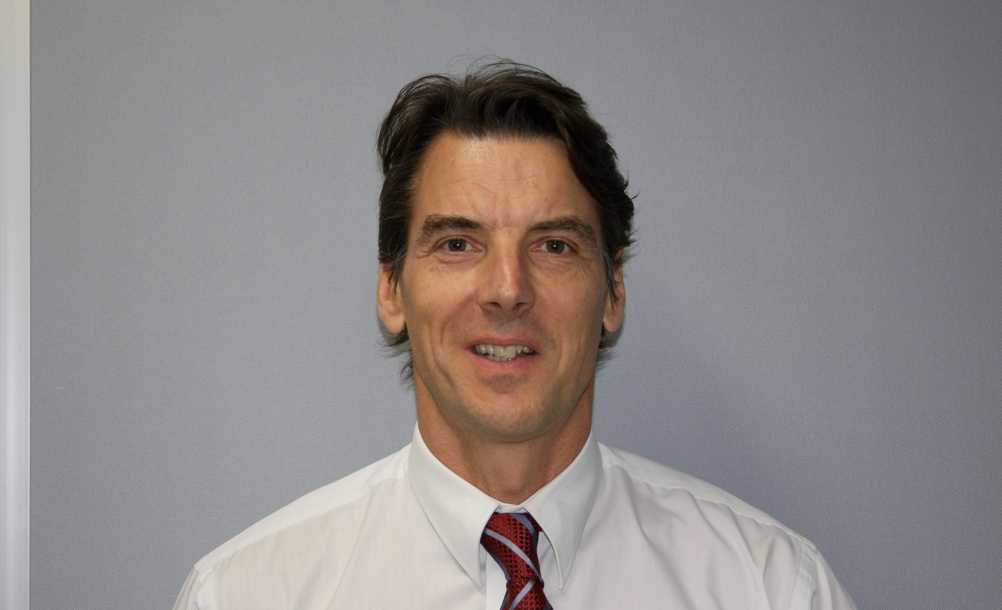RUGBY CODES RESEARCH GROUP – MEMBER

Edmond Sorich BSc

Research specialisation: Research design and biomarker analysis.

Experience: My area of expertise is exercise recovery and associated biomarkers. Most specifically, recovery and performance based markers. With years of experience gained from participating at a representative level across sports and also mentoring sportspeople across a wide range of disciplines, I am able to adapt lab testing to maximise on-field performance.
Professionally, I am a qualified scientist with expertise in biochemistry. I have been involved in the medical science industry for over 30 years and have experience as a scientist and manager in diagnostic, research, specialised and integrative pathology and clinical trials. During this time, I have also been involved in the health industry for 18 years overseeing two successful health and lifestyle businesses.
All the above has led me directly into the TBI (chiefly concussion) space.
The last four years has seen me develop partnerships, collaborations and networks ranging both locally and internationally ranging from clinicians, researchers, professional sporting organisations and athletes across multiple codes.
Most recently, Glia has completed a clinical trial involving a biomarker for TBI with plans for further and larger trials. These will also include other modalities to help accelerate validation. Most excitingly, the biomarker shows real promise for 'quantifying' injury as well, hence providing a tool for return to play (RTP), work, battlefield, etc.
I am passionate about bridging the gap between clinician and patient.

Research overview: Worked closely with The Alfred Hospital ED organising a clinical trial with plans for a larger multi-centre trial. Completed studies in the US with college athletes across American Football and soccer. Continuing formal discussions with the AFL. Also, discussions around potential studies with Rugby, League and soccer codes via their player associations and/or club representatives. Currently focussing on both the US and Australian militaries re plans focussing on ‘sub-concussive’ blows bought about by explosive devices and potential longer term effects such as PTSD. Formal discussions with EU Center TBI and access to trial samples for testing using our biomarkers.
Glia is working with a group in the US re the real potential of a Point of Care (POC) device to assist with immediate diagnosis at field of play, bedside and battlefield.

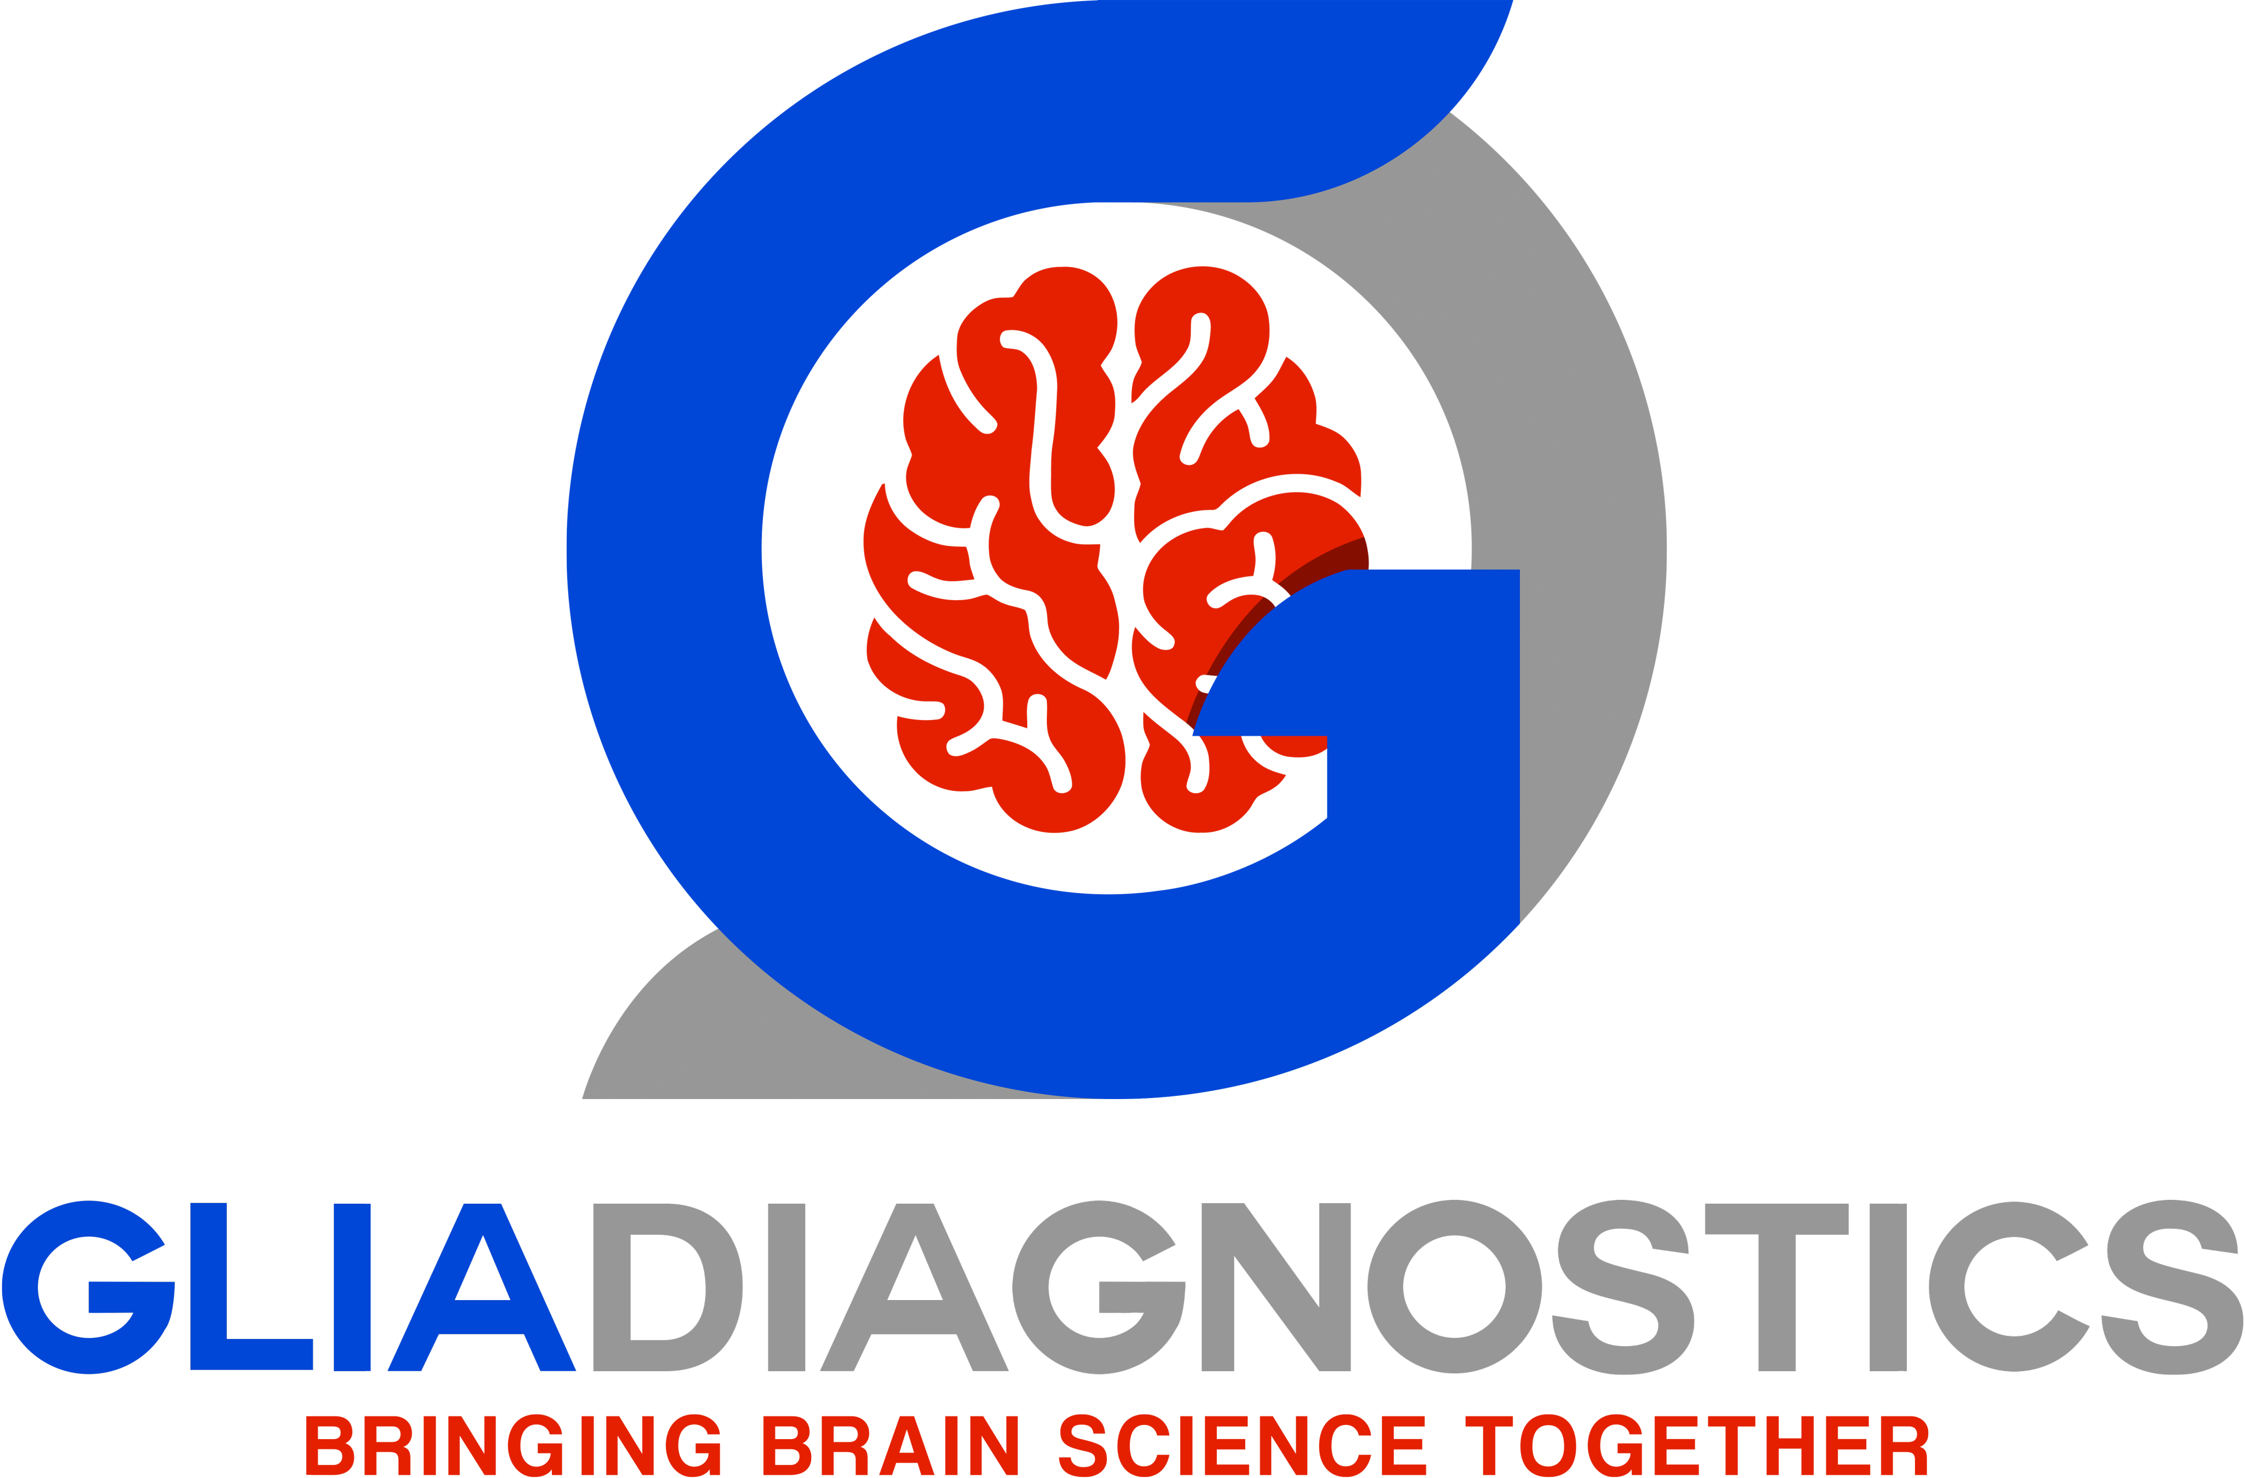Postgraduate supervision: N/A

Edmond Sorich
Director Glia Diagnostics
M: + 61 450507237
E: ed@gliadiagnostics.com www.gliadiagnostics.com PO Box 138N Armadale VIC AUS 3143

Research publications: Currently 1 peer reviewed publication. Example publications:
Mitra B et al. Plasma micro-RNA biomarkers for diagnosis and prognosis after traumatic brain injury: A pilot study. J ClinNeurosci (2017), http://dx.doi.org/10.1016/j.jocn.2016.12.009

1

