**RUGBY CODES RESEARCH GROUP – MEMBER**

**PhD Student Mike Hopkinson**

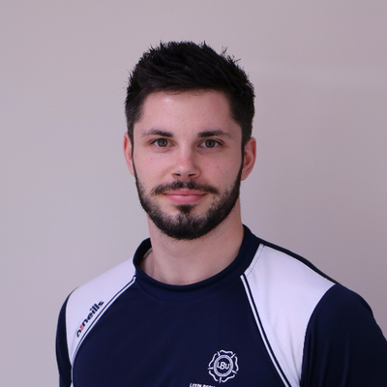 MSc, FHEA

**Research specialisation:** Tackle injury mechanisms in rugby league.

**Experience:** 1st class degree in Sport & Exercise Science, Masters degree in Sport & Clinical Biomechanics. 1 year experience as a strength and conditioning coach, with specific rugby experience at Bradford Bulls RLFC. Currently a Graduate teaching assistant, PhD student at Leeds Beckett University and first team performance analyst at Harrogate RFC. I have experience with a vast variety of biomechanical equipment and software, including Bioware, Simi motion and Qualysis. Additionally, during my PhD I have gained advanced skills in Sportscode, Nacsport and R Software.

**Research overview:** Moving into my final year of my PhD studies, my project focuses on determining injury mechanisms in a rugby league tackle. I have worked closely with elite practitioners (coaches, performance analysts and referees) within rugby league to determine variables which are associated with a modern rugby league tackle scenario. From this, I am using videos of all Super league games of the 2017 and 2018 season and injury data from provided by the RFL to determine variables which are more likely to occur during an injurious tackle, than non-injurious. If new information is found from the study, potential rule changes or tackling strategies can be put in place to make the game and specifically the tackle scenario safer for players.

**Postgraduate supervision:** Currently 0, but I have supervised 1 undergraduate to completion and have taken another 3 this year.

**Research publications:** 1 conference paper (to be presented at ISPAS 2019 Budapest).

,

