VICON Darts Interaction Programme

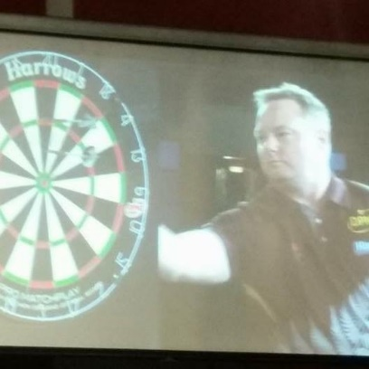
The ISBS2018 conference Platinum Industry Partner, VICON, has supported a world first Darts Biomechanics Programme with AUT SPRINZ.

Graeme Lowe (The Doctor Pro Circuit darts player) has had regular biomechanics analysis and technique interventions from March to August 2018 leading up to the ISBS2018 conference in Auckland.

At the ISBS2018 kiwiana & industry partner playing field opening reception interactive event, Graeme will be on stage showing his technique. A video will play on the large atrium screen showing Graeme’s biomechanics programme work over the six months, and his improvement in performance via the use of applied biomechanics.
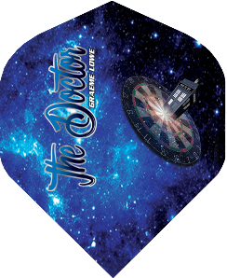
Graeme will also be throwing the winning darts at the ISBS2018 Jigsaws to select the winners on the night (each delegate gets a jigsaw piece in their delegate bag, and puts their piece into one of the 12 jigsaws, which is then mounted on the dart board for Graeme to throw at with his right hand, left hand, and then blind folded. The ISBS President, Vicon CEO, and ISBS2018 delegates will also throw darts to help determine prize winners as the puzzles are completed.

Player Profile – Graeme Lowe
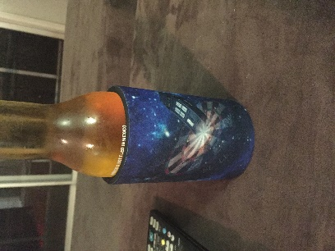
Nickname: The Doctor
Date of Birth: 17 March 1968
Home Town: Auckland, New Zealand
Residence: Brisbane, Australia
Occupation: IT Project Manager/Business Analyst
Darts: Red Dragon Peter Wright Snakebite Blue PL15: 22 gram
Walk-on Music: Doctorin’ the Tardis (Timelords)

2016-2017 Highlights:
- DPNZ Ranking: 10
- 2017-2018 PDC World Championships Playoff Qualifier
- 2017 North Island Representative at Australasian Championships

Since his first game of darts in March 2014, Graeme has enjoyed a rapid rise in the sport. His first game came about because that’s where his parent were going to be on their wedding anniversary, but he quickly fell in love with the game and, with some advice from a visiting Simon Whitlock, rapidly improved to represent his local club.

Graeme’s nickname, The Doctor, was provided by his Dad, Bill, when Graeme would turn up at his parents to watch the professionals carrying his black darts case. His Dad would turn to his Mum, Wendy, and say “The doctor’s here!”. His Dad then got a shirt made for Graeme’s birthday and asked him to where it at a DPNZ tournament, and it stuck!

In 2016, Graeme played his first tournament at a DPNZ Grand Prix in Auckland. Qualifying through section play on both days, he caught the tour bug and played the entire 2016/2017 DPNZ Tour. His 10th position qualified him for both the DPNZ Top 16 Playoff for the 2017/2018 PDC World Championship and for North Island Representation at the 2017 Australasian Championships in Dubbo, NSW. Graeme also earned seeding to the 2017 Oceanic Masters, which saw winner Bernie Smith earn a place at the 2017/2018 PDC World Championships.

Currently competing on the 2017/2018 DPNZ Tour, Graeme has added the 2018 DPA Tour (the Australian counterpart to the DPNZ Tour) to his schedule. This will see have seen him compete in Timaru, Auckland, Sydney, Wellington, Melbourne, Queenstown, Warilla, Brisbane and Hobart by the end of both tours, in addition to his representative and club duties in venues around South East Queensland. It would be fair to say that Graeme loves his darts!

The NZ and Australian Pro Tours are feeder tours into the Professional Darts Corporation (PDC) Tour which is based in the UK. Graeme will be competing in the North Island and NZ National Championships in Wellington and Invercargill, respectively. In addition, he will be playing in the qualifying events for the Auckland Darts Masters, the Brisbane Darts Masters and the Melbourne Darts Masters, all PDC events televised live worldwide. Last year Graeme made the quarter final of one of the qualifiers and the semi-final of another. This year he hopes to make one of the televised events. Graeme is also well placed to again play in the NZ Top 16 playoff for the PDC World Championships in London. That event is the biggest darts tournament in the world with tens of millions of viewers every year.

