Student night at the Ngā Wai o Horotiu Marae

Who: Limited to the first 120 ISBS2018 conference students who register.
When: Tuesday 11th Sept 7:00-9:00.
Where: AUT Ngā Wai o Horotiu Marae located on the corner of Wellesley and St Paul's Street
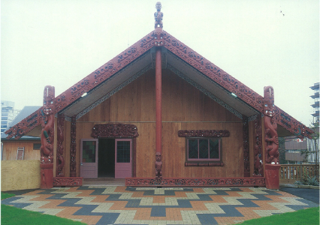
What: Marae (Māori meeting grounds) and hangi (food) and cultural experience provided by AUT kapa haka Tītahi ki Tua
NOTE: Please come appropriately dressed to the Marae. Men should at least wear dress pants and a tidy shirt, while women should wear either a knee length skirt or tidy dress pants. You will remove your shoes upon entering the Marae.
Cost: None as provided as part of the ISBS2018 student registration.

Order of Proceedings
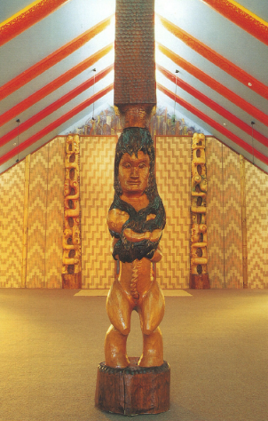

6:50 Congregate at the AUT Ngā Wai o Horotiu Marae gateway
Manuhiri will congregate at the waharoa (gateway) of the marae and wait for the karanga (call of welcome) from the kaikaranga (the host caller).

7:00 Welcome onto AUT Ngā Wai o Horotiu Marae by Dr Valance Smith

Kaikōrero Address
The Kaikōrero will welcome the manuhiri (ISBS2018 student visitors) to Ngā Wai o Horotiu (marae), and will address the assembled company and explain the protocol and proceedings.

7:30 Hangi at Te Kaipara (Wharekai) and AUT kapa haka Tītahi ki Tua (Māori students association)

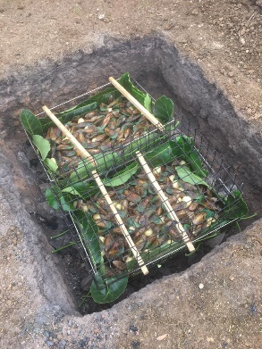
Kai and Kapahaka
The manuhiri are then invited to have a kai (meal – hangi of food cooked in the ground) to complete the formal welcome and begin the lifting of tapu (cultural sanctions). The visitors now become tangata whenua or part of the marae and are expected to participate in the other activities that occur on the marae.

The Kaikōrero will introduce the AUT kapahaka group, Tītahi ki Tua, who will perform the haka to the assembled company.

NOTE: Students will have the opportunity to learn the haka at the ISBS2018 breakfast sessions, and participate in performance of the haka at the closing ceremony of the conference.

9:00 Finish

TE PŌHIRI KI NGĀ WAI O HOROTIU - THE WELCOME TO NGĀ WAI O HOROTIU MARAE
Welcome to Ngā Wai o Horotiu.
http://www.aut.ac.nz/community/maori/nga-wai-o-horotiu-marae

AUT Ngā Wai o Horotiu marae
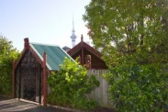
AUT Ngā Wai o Horotiu marae serves as a whānau, cultural and spiritual centre. Ngā Wai o Horotiu is one of the ways in which AUT actively acknowledges the importance of the principles of the Treaty of Waitangi and expresses our deeply held belief that AUT is a centre of learning not only for all peoples, but also a particular place where Māori have a special and distinct role. Ngā Wai o Horotiu is a place where you can stand proud. It is a tangible sign that the University is a learning organisation and one that is always seeking new ways of doing and being. Ngā Wai o Horotiu is the focal point that embraces the history of Māori and welcomes the many rich and diverse cultures at AUT.

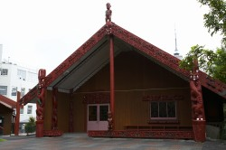
Te Pūrengi (meeting house)
The wharenui was named Te Pūrengi by the local iwi Ngāti Whātua. The name represents the ropes, which help keep the mast strong and sturdy on its long journey. Te Pūrengi is the focal point of 'Ngā Wai o Horotiu' embracing the history of Māori and the many rich and diverse cultures of AUT.

Te Kaipara (the dining room)
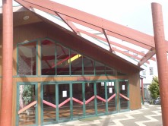
The dining room is called Kaipara after the Kaipara Harbour. Ngāti Whātua traversed the Kaipara from the North. The word ‘para’ is a reference to the para fern which is a traditional Māori delicacy. Kai-para means ‘to eat the para fern’. It’s a fitting name for our dining room. Kaipara – the house of gourmet food.

Protocol

Marae – The place of welcome
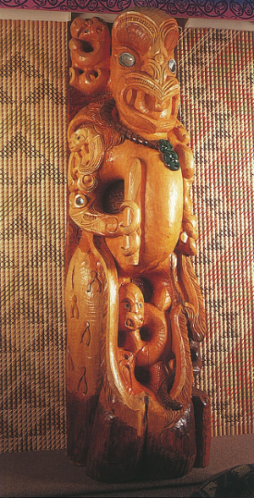
You are manuhiri (a visitor) to Ngā Wai o Horotiu Marae, and you will be welcomed as a guest and therefore you should be dressed appropriately. For this kaupapa (occasion), tidy casual wear should be worn. Men should at least wear dress pants and a tidy shirt, while women should wear either a knee length skirt or tidy dress pants.

Generally, the pōhiri protocols explained here can apply to most marae throughout New Zealand. The pōhiri recognises the coming together of two groups that are separated not only physically but also spiritually. It is a profound acknowledgement that we are all creatures of a spiritual realm. The marae ātea (area) is a tapu (culturally sanctioned) space and has been referred to as, ‘te umu pokapoka a Tūmatauenga’, (the fiery ovens of Tūmatauenga - the God of War).

Karanga – The call of welcome
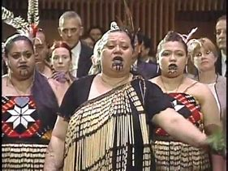
Manuhiri should congregate at the waharoa (gateway) of the marae and wait for the karanga (call of welcome) from the kaikaranga (the host caller). You embark onto the marae ātea as waewae tapu (first time visitors). The karanga will be answered by skilled women in the visiting group who are able to reply appropriately. The karanga is highly spiritual and is the first act by which manuhiri and tangata whenua (hosts) begin the act of union and this is administered by women only.

Whakaeke – Approaching the meeting house
During the karanga the group advance slowly towards the wharenui (carved meeting house). Before reaching the wharenui the manuhiri briefly pause and pay their respects in memory of those who have passed away. Once this act is done the visitors may proceed further. At Ngā Wai o Horotiu Marae, whaikōrero (formal speeches) will take place inside the wharenui and not on the marae ātea as other marae do. Before entering the wharenui, you must remove your footwear; you will be seated to the right of the entrance with your speakers taking the front seats. The principle of removing ones shoes is also a symbolic one. It represents the leaving of the dust of Tūmatauenga (God of War) outside so that it does not soil the house of Rongo (God of Peace). During the formal part of the whaikōrero, the men will fill the first front row of chairs, followed by the women.

Whaikōrero – Formal speech
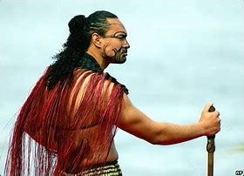
The whaikōrero (formal speech) is an intricate speech that recognises and acknowledges special unions of realms, of common themes and of specific representation. During the whaikōrero special recognition is also mentioned about, the elements and the environment, the land and sky, those deceased, those present and the ultimate purpose of the days gathering. Each whaikōrero is followed by a waiata (song). The waiata is an act of support for the orator and the words of his speech. Singing a waiata in support of the speaker also displays the unified strength of the visiting group. So, taking time to practise a waiata before the pōhiri day makes all the difference.

Koha – Expression of appreciation
The koha, an expression of appreciation and respect for the hospitality of the hosts, is laid down by the last speaker of the manuhiri; this is money sealed in an envelope. A koha can also be seen as an offering or donation to the marae and hosts that alleviates the pressures of hosting the visitors for their length of stay. A representative from the tangata whenua will pick up the koha accompanied by a speech of thanks and gratitude.

Hongi – Pressing of noses
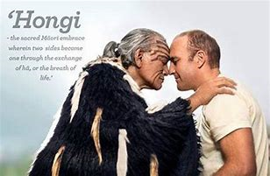
Once the pōhiri has concluded, manuhiri are then invited to come forward in a line from a directed position to harirū (shake hands) and hongi (pressing of noses). It is through this physical ritual encounter that peace, oneness in thought, purpose and hope is expressed. The hongi is a sign of life, symbolising the action of the gods in gifting humans the breath of life. Through the action of harirū and hongi, Māori believe that the shared life force is permanently established and the spiritual and physical bodies become a living entity. Men hongi men, men hongi and kiss women. Women hongi and kiss women.

Kai – Meal
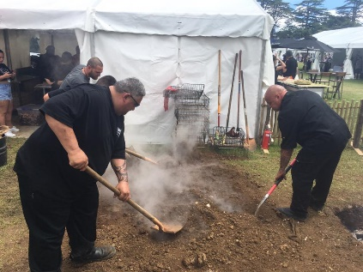
The manuhiri are then invited to have a kai (meal) and this completes the formal welcome, thus begins the lifting of tapu (cultural sanctions). The visitors now become tangata whenua or part of the marae and are expected to participate in the other activities that occur on the marae.

This hangi is 'real' hangi where the food is cooked in the earth
https://www.facebook.com/HangiMasterNZ/

Nau mai, piki mai, tauti mai… Welcome, welcome, welcome…

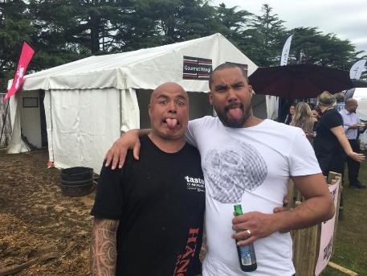
Waka Huia documentary
Ngā Wai o Horotiu marae was featured on TVNZ's Waka Huia show. AUT past and present staff tell us about the names and stories behind this marae.

Read more here
Download a pdf version of Ngā Wai o Horotiu Marae booklet.

