The Repercussion Group
Endorsing members (presented in alphabetical order) by Stephen T. Casper, Paul Chazot, Amanda Ellison, Judith Gates, Irene R. Gottlieb, Conor Gormally, Malayka Gormally, Karen Hind, Patria Hume, Doug King, Elizabeth Sandel, Alice Theadom, Sally Tucker.

Run It Straight: A Call to Action Against a Perfect Brain Injury Delivery System

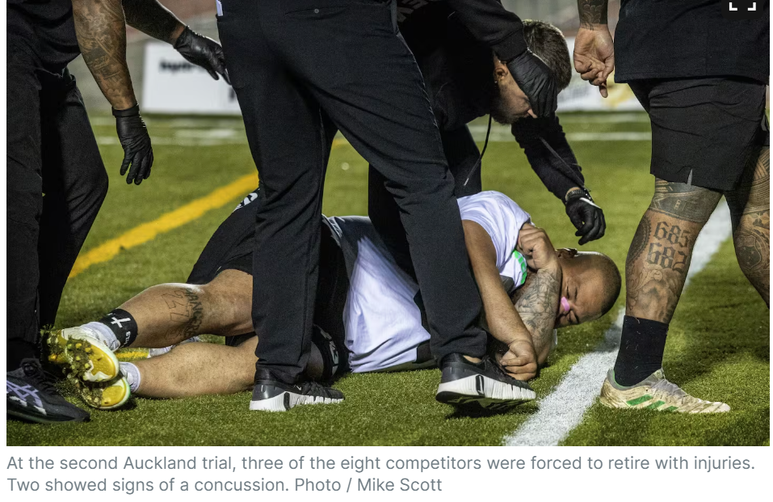
Source: New Zealand Herald

The Repercussion Group submits this White Paper to warn the public, policymakers, sports organizations, and social media platforms about the rise of the “Run It Straight” social media challenge and related for-profit competitive events. These businesses basing for-profit “sporting” events off of a dangerous social media challenge epitomizes the transformation of violence into entertainment, augmented by social media.

The Repercussion Group is a stakeholder group of academics, researchers, clinicians, caregivers, and advocates from around the world seeking to raise awareness and drive policy change related to the immediate and long-term effects of repeated head impacts in sports. Many of us are caregivers to people with impact-related neurodegenerative diseases. Others live with the consequences of concussions that continue to affect daily life. All of us know individuals who are suffering from dementia and other conditions that have been linked to brain injuries.

“Run It Straight,” involves two participants running at each other at full speed and colliding, with the winner decided by who hits the hardest and stays upright. These events are recorded, shared, and amplified on social media platforms, including YouTube, Facebook, and TikTok, where they reach broad audiences, often including younger viewers. The popularity of this challenge has inspired for-profit competitive events, including Run It Straight Official, and the RUNIT Championship League. These activities, like so-called “Dwarf Tossing” before them, turn real human risk and harm into a spectacle. They represent what Medical Historian Stephen Casper calls “perfect brain injury delivery systems”—efficient packages of harm that transform the risk of severe brain injury into viral entertainment.

The biomechanical forces involved in these collisions are equivalent to being in a car crash without a seatbelt. These forces have the potential to cause death or lifelong disabilities that can affect every aspect of a person’s life. Yet the RUNIT Champions League and the “Run It Straight” social media challenge on which RUNIT is based are framed as merely a challenge, a game, or a sport, with no mention of the catastrophic potential for head and neck injuries, acute brain damage, or long-term neurological diseases.

It’s critical to emphasize that, although participants may choose to engage in such activities, their choice is neither fully free nor fully informed. Social, financial, and peer pressures can drive individuals to participate in these risky contests without a proper understanding of the level of risk they are taking on. Are social media companies incentivized to build algorithms to generate excitement and normalize the practice for the world’s youth, turning injuries into clicks and views? Absolutely. Are organizations like the RUNIT Championship League further incentivized to maximize the violence of their ‘sport’ to drive engagement and differentiate themselves in an oversaturated market? Yes. This is an example of how social media’s role as both an incredibly profitable global industry and a cultural superhighway incentivizes social trends that turn fantasy into reality with foreseeable and terrible consequences. The real cost of these events and trends is borne by those who get hurt, their families, the health care systems––and not by the audiences who cheer them on or the businesses who profit by ignoring the harm their products create.

It is our ethical duty to raise awareness about the dangers of “Run It Straight,” the RUNIT Championship League, and similar activities. We urge sports organizations, policymakers, and social media platforms to acknowledge the seriousness of these risks and take action.

Recommendations
- Clearly warn the public as to the fragility of the human brain to concussive or subconcussive blows. Quite simply, the human body is not designed to withstand blows to the head.
- Clearly warn the public, athletes, and parents about the dangers of “Run It Straight,” the RUNIT Championship League, and similar activities, emphasizing the risk of brain injury, death, disability, and long-term neurodegenerative diseases.
- Develop and enforce bans on “Run It Straight” events and the RUNIT Championship League in organized sport and on social media platforms, including demonetizing videos that promote such activities.
- Educate social media companies about the health risks of these videos and their responsibility to moderate content that endangers human life.
- Recognize that “Run It Straight” and the RUNIT Championship League are not a sport but a perfect brain injury delivery system that exploits participants for entertainment.
- Develop educational resources for schools and communities that emphasize safer sports, healthy exercise and recreational activities, and explain the risks of uncontrolled high-impact collisions.
- Encourage policymakers to pass urgent legislation banning the organization, promotion, and monetization of “Run It Straight”-style events, including the RUNIT Championship League.
- Call on researchers to study the pathological, neurological, social, and economic repercussions of these types of activities and to share the findings within the public domain.

Conclusion
“Run It Straight” and businesses like the RUNIT Championship League are the latest in a long line of spectacles that commodify violence and human suffering. Clinicians, scientists, policymakers, and platform managers have an ethical obligation to protect vulnerable individuals from these perfect brain injury delivery systems and improve our cultural understanding of the human brain’s vulnerability to collisions.

